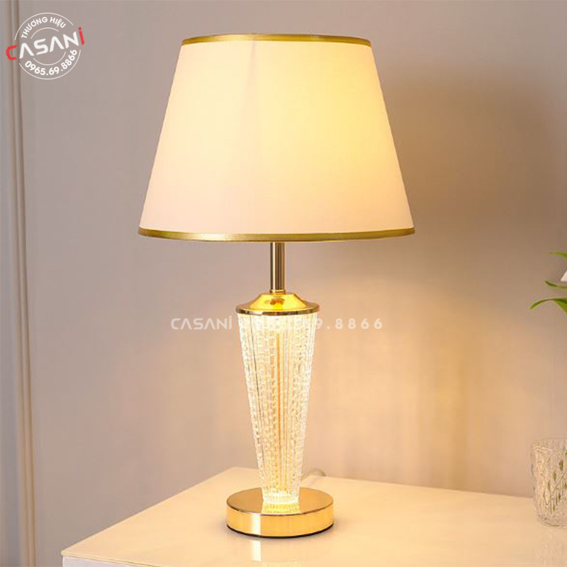

$26,40

PRODUCT INFORMATION

- Product name: Decorative table lamp

- Product code: DDB-2506

- Material: alloy lamp base, glass lamp body, fabric shade

- Design: modern

- Size: 48cm x 30cm

- Bulb type: LED or incandescent (can be easily purchased on the market)

- Status: In stock

- Warranty: 12 months

- Application: in work, study, decoration,..